
Chai’s Writing Samples

Table of Contents
Branching dialogue and character brief description 2
Combat Barks 7
Item Descriptions in the Adventure to Nowhere 9
Screenwriting, dialogue focus 12
Quest Design, RPG design: Current of Dread 14

BRANCHING DIALOGUES & CHARACTER BRIEF DESCRIPTIONS

[[Entrance of Mount of Enigmatic Valor]]
MC after being dropped off by a bus.
“Oh well, the important thing is to conquer this place… And to prove User0123 that I can touch some grass!”
^{[[Intervention]]}
Someone intervene his inner monologue
“If that’s your achievement, you can just touch it here outside and leave.”
^{[[MC’s response]]}
MC looks at his left, on where the voice is coming from
“I’m not the kind of person to back down.”
^{[[Introduction]]}
^{Politely}
“I see, let me introduce myself; my name is Natasha Phony.”
^{[[Attempt of companionship]]}
Offering MC a hand to this journey
“You should tag along with me, this place is too dangerous to be alone.”
^{[[Doubting]]}
MC analyzing and observing Natasha Phony
“Just your name itself doesn't sound trustworthy at all.”

^{[[MC decisioning]]}
^{Natasha giggles}
^{“I get that a lot haha.”}
^{“So let's head together?”}
^{[[Yes]] or [[No]]}
^{[[Yes]]}
^{MC decided yes}
“Okay, let's see how trusty you are.”
^{[[Natasha responded if yes]]}
^{Natasha giggles}
^{“Haha! Okay then, let’s go!”}
^{[[MC’s remark]]}
^{“You sure giggle a lot, huh?”}
^{[[No]]}
^{MC decided no}
^{“I’m all good for now.”}
“I’ll just look around for a bit.”
^{[[Natasha’s response if no]]}
Natasha tried to hide her disappointment with a smile
^{“Oh okay, I understand.”}
^{“Let’s see each other later.”}
^{MC (Mark Chandler)} 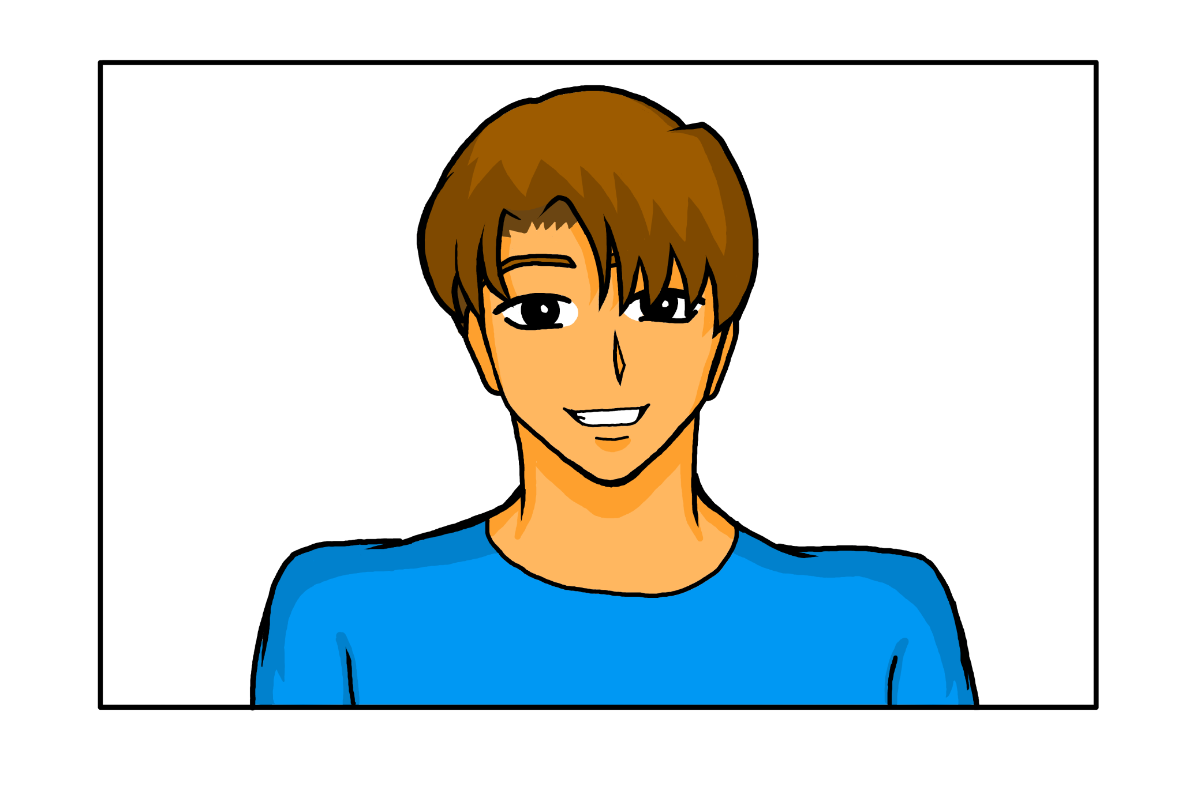
Occupation: The renowned top 1 game streamer, he gains income from streaming games.
Appearance: In his mid-twenties, fresh graduate, lean but not athletic, always wears the same blue shirt and sweat pants claiming that being an mc a.k.a
The “main character” means to have a remarkable appearance; and yet he chooses his as the simplest. His eyes are not puffy which is not usual for an
all-nighter gamer, his genes save him.
Personality: He is incredibly boastful especially when it comes to his skills in games. He does not degrade nor insult his opponents to the game but rather to praising himself or when someone praises him expect his answer will be: “I know right?” But MC is really competitive especially when someone insults him, this sounds like a challenge to him like a quest in a game where you need to conquer it before proceeding it into the next level. MC has a strong willpower to his own capability to adapt in any situation swiftly—but would he conquer this one?
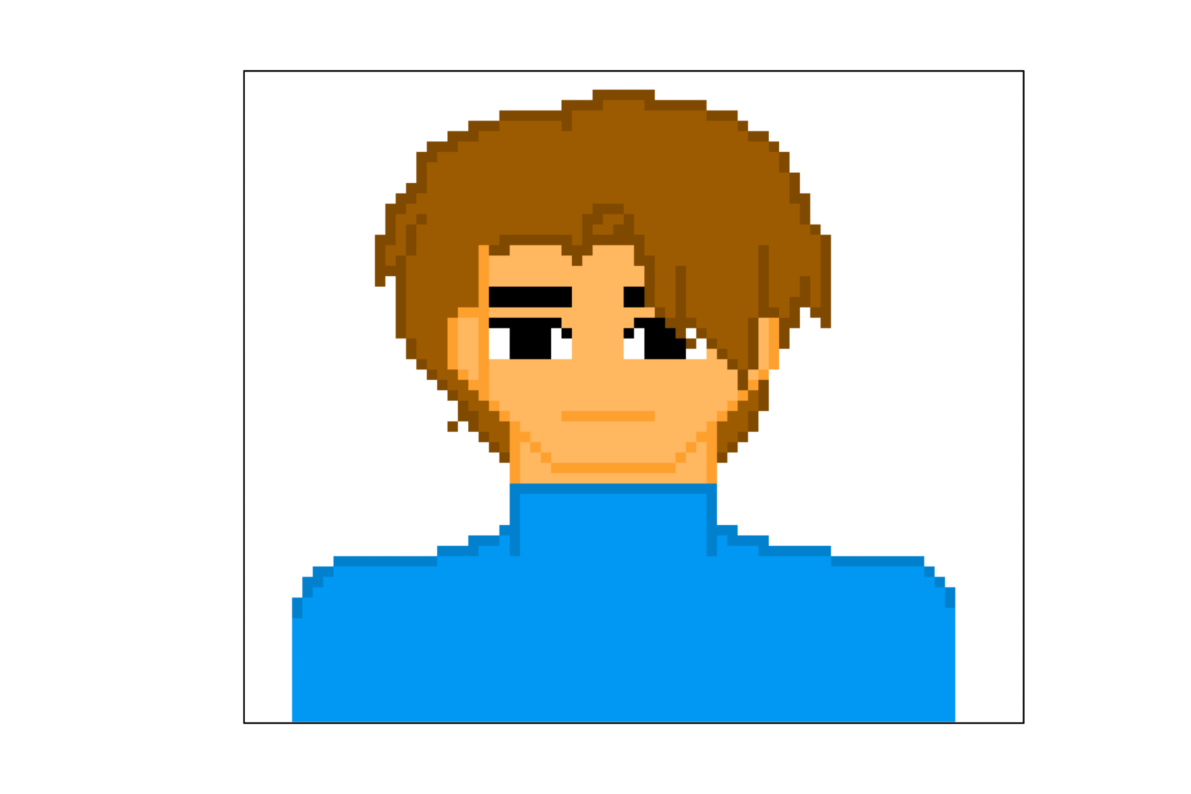
In game dialogue sprite
Ideal: Despite MC being boastful, he sincerely appreciates his fans and viewers of his game streaming.
Flaw: Because of being overly competitive, his actions mostly lead him into reckless consequences.
Relationship: Close friends with Jeff and Ran which are famous game streamers as well. They are the ones that MC could count on when it comes to team games.

^{In gameplay sprite}
Backstory: He is the renowned top 1 game streamer for the past 3 years, he is known for being boastful without insulting or degrading his opponents which is the reason why a lot of viewers attract this kind of persona that leads him to gain a huge fanbase. As soon as he graduates college, he focuses his life in streaming games and competing in them at home and because of that it deprives him from living his life in the outside world. One day, after MC played a game tournament with his friends he checked his social media to see any updates about his gameplay; his feed was bombarded with his fans praising him for being skilled and excellent to the game, yet he encountered one commenter, User0123, stating: “He’s only good at playing games, live a life dude and touch some grass.” It is his first time to be insulted and encounter a basher, and what he hates the most is that it is a fact that he is deprived from the outside world but he is living his life, right? To prove that commenter wrong he searches outside activities that are worth achieving; after a long and thorough research that nothing piques his interest he finally saw hiking in “Mount of Enigmatic Valor” it is the most infamous mountain known in the entire world seeing that no hikers nor travellers surpassed this mountain. MC saw this article and was excited with this challenge. He feels like it is a quest to conquer his life to test his courage—Would going to the Mount of Enigmatic Valor achieve anything in his life or would it be the end of it?

^{COMBAT BARKS}
Barks for players in hypothetical battle in the Mount of Enigmatic Valor.
^{Character notes: In combat:}

^{CHARACTER} | ^{ACTION} | ^{LINE}
^{Player} | ^{Pursue} | ^{“We’re just getting started!”}
^{Player} | ^{Pursue} | ^{“Don’t you dare escape!!”}
^{Player} | ^{Punch(left)} | ^{“Hah!”}
^{Player} | ^{Punch(right)} | ^{“Taste this!”}
^{Player} | ^{Kick(left)} | ^{“Here I come!”}
^{Player} | ^{Low HP} | ^{“Argh! Cheater!”}
^{Player} | ^{Low HP} | “There’s no way you can beat me!”
^{Player} | ^{Defeated} | “No! But I still have an adventure… that awaits me…”
^{Player} | ^{Defeated} | ^{“No! My adventure ends here…”}
^{Player} | ^{Conquered} | ^{“As expected to you, MC!”}
^{Player} | ^{Conquered} | “I knew from the start that victory was mine.”

ITEM DESCRIPTIONS IN THE ADVENTURE TO NOWHERE

 | ^{CHEST}  Is there anything helpful in this chest?  - ^{Food (+HP)}  - Potion (+Character fighting skills)  - ^{Armory (+Shield)}
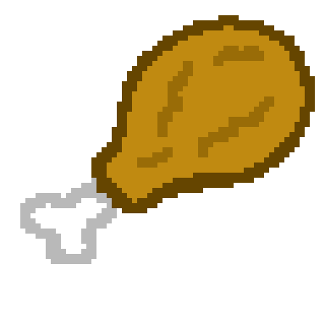 | ^{CHICKEN}  This tastes ridiculously good for a chicken found in a random treasure chest, it is indeed a treasure!  - ^{+5 HP}
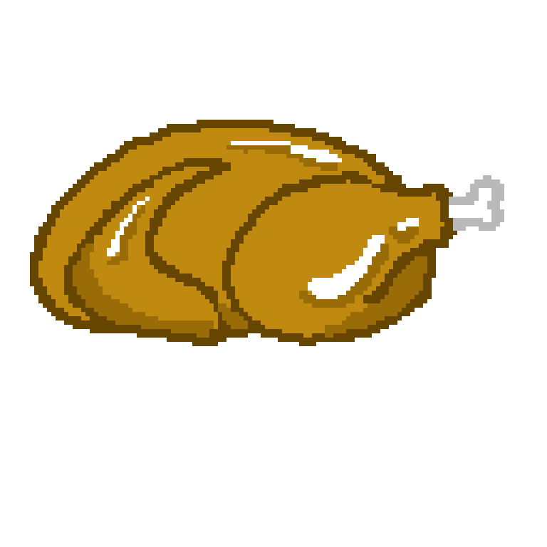 | ^{WHOLE CHICKEN}  A whole chicken hiding inside a treasure chest? AND WHY IS IT SHINING!?  - ^{+10 HP}
 | ^{HEALTH POTION}  It may look suspicious knowing it’s just found in a random treasure chest but tastes like strawberries and cherries.  - Instantly replenish the player’s HP.
 | ^{SHIELD POTION}  It may look suspicious knowing it’s just found in a random treasure chest but tastes like blueberries.  - Boost the DEF and shields the player for 3 minutes.
 | ^{COURAGE POTION}  It may look suspicious knowing it’s just found in a random treasure chest but tastes like apples and pineapples.  - Boost the player’s strength ATK, making him invincible.
 | ^{ARMORY}  Jackpot! Something to protect the whole body!  - Shields the player until the armory is all shattered.  - It is made with steel therefore it will protect you for sure in a long time!

^{SCREENWRITING, DIALOGUE FOCUS}
^{INTRODUCTION SCENE:}
^{MC gaming, facing the screen}
Winning the game and his team congratulate him.
^{Jeff:}
^{“You win that dude!”}
^{MC:}
“Tell me something that I don’t know.”
^{Jeff:}
^{“As cocky as always.”}
^{Their other friend agreed.}
^{Ran:}
^{“Yeah.”}
^{Ran:}
^{“I’m going to sleep now guys.”}
^{Jeff:}
^{“Me too.”}
^{Jeff:}
^{“Get some sleep too, MC.”}
^{MC:}
^{“Yeah I will, gg guys.”}
^{Jeff:}
^{“GG!”}
^{Ran:}
^{“GG!”}
^{Ran and Jeff left the call.}
MC scrolls to his social media checking his fans sharing his game stream and as usual they showered him with compliments.
But one commenter catches his eye and stating:
“He’s only good at playing games, live a life dude and touch some grass.”
^{MC became furious}
^{MC:}
“What do you mean, incapable of touching some grass!”
He stands up and quickly realizes that the person that commented is right

^{He sits again}
^{MC:}
^{“He does have a point.”}
He goes to google and searches on the activities with zero digital interaction and sees hitch hiking.
6 Hitch hiking became the one that piqued his interest as he scrolled down further, he saw the places that are recommended to hitch hike. Top 1 is the “Mount of Enigmatic Valor”. As he stared at this place and continued searching for more stuff about it
^{He scoffed}
^{MC:}
“A top 1 place to hitch hike is suitable for the top 1 gamer of all time.”
As he scrolled further, he saw that people who hitch hike there never came back. His eyes widened... not from fear but... from excitement?
^{MC:}
“This is even more interesting!”
It states in the article it is recommended to have experienced martial arts skills to fight the dangers.
^{MC:}
“Okay, punch and kicks ain't new for me! Let’s do this! Tomorrow…”
^{Go to bed}
^{The next day}
^{Get your ass out of the bed!}

QUEST DESIGNS, RPG DESIGNS: CURRENT OF DREAD
Adventure to Nowhere is a NPC Guide System whereas it tests the gut feeling of the player whether they will trust the NPC’s guides to proceed or to just find their way around.

^{ACT 1: PROVOKE}
^{INTERACTIVE}
Setup: MC is a world-renowned top 1 game streamer whose identity revolves around dominance, precision, and online validation. Every night after streaming, he scrolls through social media to bask in praise from fans who admire his unmatched skills. One evening, however, a single comment cuts through the noise—mocking him for being “He’s only good at playing games, live a life dude and touch some grass.”” Though buried among compliments, the remark pierces his pride. For the first time, he feels insecure about his life outside the digital arena. Determined to prove the commenter wrong, MC searches for a real-world challenge with zero digital interaction. His search leads him to the infamous Mount of Enigmatic Valor, the most popular hitchhiking destination known for its thrill—and for the mysterious disappearance of those who attempt it. Excited by the danger, MC decides this will be his ultimate proof of worth.

ACT II: COMMENCE OF THE JOURNEY IN THE MOUNT OF ENIGMATIC VALOR
^{BATTLING WITH MONSTERS}
MC begins his journey to the mountain, leaving behind his streaming setup, followers, and online persona. As he climbs, the environment becomes increasingly hostile and surreal. Strange sounds echo through the fog, trails seem to shift, and monstrous figures lurk in the shadows, feeding off his fear and doubt. The climb tests not only his physical endurance but also his psychological stability. Without an audience to impress, he feels exposed and uncertain. The mountain appears to respond to his pride and desperation, confronting him with manifestations of his ego and insecurity. At the midpoint, he realizes the mountain is not just a physical challenge—it preys on those who climb for validation, trapping hikers who cannot let go of their need to prove themselves.
INTERACTION WITH THE FIRST COMPANION:
^{NPC GUIDE SYSTEM}
Natasha Phony is a traveller as well, it is up to the player if you will trust her or not.
^{[[If yes]]}
You will protect Natasha Phony and she’ll leave you behind eventually.
^{[[If no]]}
There are a lot of NPC’s you’ll discover that will either help you or not, the choice is yours.

^{ACT III: SUMMIT}
^{INTERACTIVE}
At the summit, MC thought his biggest obstacle were the monsters and creatures he fought and especially to the people who he doubts to trust along the way. Yet it is his ego to be the best: a monstrous embodiment of his online persona, powerful but hollow, sustained only by applause and attention. The commenter’s insult was a blessing in disguise because he finally knew that his world doesn’t only exist virtually, there is so much out there that he is overlooking. The confrontation forces him to choose between clinging to his pride or letting go of the need for validation. Instead of fighting with skill alone, he accepts his flaws and releases his obsession with being “top 1.” This act weakens the mountain’s hold, allowing him to overcome the supernatural force. MC survives and returns home transformed. He resumes streaming, but with a new perspective—valuing authenticity over dominance. His journey resolves not in proving others wrong, but in redefining what true strength means and finally he did not only exist online but he actually lives his life.
^{AT THE SUMMIT:}
The player will go back down to the Mount of Enigmatic Valor but this time, monsters and creatures are passing by through him.
They will not attack you as you conquer them.
The player will ride a bus on the way home and he will be renowned as the “The Survivor of the Mount Enigmatic Valor.”

